Trame cours - C01 - Révisions, découverte de Java

https://openclassrooms.com/fr/courses/6173501-debutez-la-programmation-avec-java/6313896-utilisez-les-variables-en-programmation

Java

compilation

byte code

variable

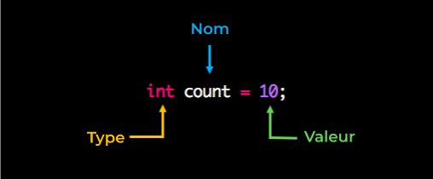

type

types primitifs

affectation

affichage

*****************

opérateur arithmétique

exo type

choisir un type approprié

TP machine

public class MyVariable {

public static void main(String[] args) {

int savings = 500;

int ongoingAllowance = 2000;

//Ajoutez 100 à votre épargne (Yeah!)

savings = savings + 100;

//Enlevez 50 à votre indemnité (Snif)

ongoingAllowance = ongoingAllowance - 50;

//Faites une mise à jour sur votre délai d'épargne

int numberOfDaysToSave = (5000 - ongoingAllowance) / 500;

//Mettez à jour à nouveau votre indemnité (encore)

ongoingAllowance = ongoingAllowance + (30 - 10) * 7;

}

}

************

saisie nombre

conversion

**************

String

String city = "New York";

String movie = "Best ever";

String pet;

String emptyString = "";

concaténation

String firstFavoriteCity = "New York";

String secondFavoriteCity = "Buenos Aires";

String favorites = firstFavoriteCity + secondFavoriteCity; // -> "New YorkBuenos Aires"

String firstFavoriteCity = "New York"

String secondFavoriteCity = "Buenos Aires"

String favorites = "My favorite cities are " +firstFavoriteCity+ " and "+secondFavoriteCity; // -> "My favorite cities are New York and Buenos Aires"

String favoriteCity = "Buenos Aires";

int numberOfTrips = 5;

String story = "I've traveled to " +favoriteCity+ " " +numberOfTrips+ " times!"; // -> "I've traveled to Buenos Aires 5 times!"

**types approfondissement**

int a = 10;

int b = 4;

int c = a/b;

int a = 10;

int b = 4;

double c = a/b;

**casting**

Portée des variables

for

int numberOfTrees = 0;

while (numberOfTrees < 10) {

numberOfTrees += 1;

System.out.println("I planted " + numberOfTrees + " trees");

}

System.out.println("I have a forest!");

I planted 1 trees

I planted 2 trees

I planted 3 trees

I planted 4 trees

I planted 5 trees

I planted 6 trees

I planted 7 trees

I planted 8 trees

I planted 9 trees

I planted 10 trees

I have a forest!

booleens

boolean vrai = true;

invers = ! vrai ;